GES6131-01

ASSIGNMENT 2

(Non-Programming Problem)

2019451170
Cho Minkeun

1. A ConvNet with following specifications is given:

(a) Fill the table and calculate the total weights, total memory per image consumed (assuming 4 bytes floating points decision) and total convolution operations during prediction.
PS: # of conv Ops includes FC layers as they are also considered as a special case of convolution.

(b) Does Receptive Field at Conv5 manage to cover the input image size?
Yes, 163is large enugh to cover 13*13

(c) Calculate how many percent of weights in the two FC layers occupied in the network.
(18874368+16777216)/ 43809472 = 81 %

2. Suppose xl-1 and xl are respectively the input and output of the residual block, F(x, W) is a function of the neuron and ⊕ is the elementwise addition. Given yl-1 = h(xl-1) + F(xl-1, Wl-1) and xl = ReLU(yl-1) as shown in the figure 1 below.
Figure 1: Residual Block

(a) By making two assumptions and state the assumptions you make, show 𝐿=𝒙𝑙−1+Σ𝐹(𝒙𝑖,𝐖𝑖)𝐿−1𝑖=𝑙−1 where L is the total number of the blocks in the ResNet.
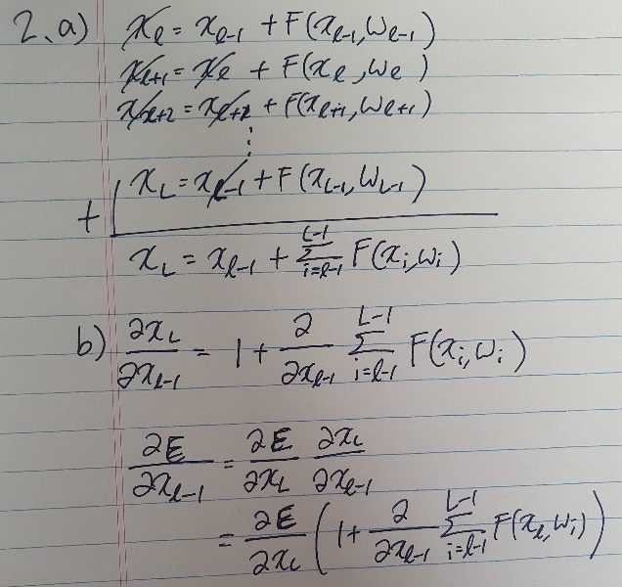

(b) Based on the equation obtained from (a), show 𝜕ℇ𝜕𝒙𝑙−1=𝜕ℇ𝜕𝒙𝐿(1+𝜕𝜕𝒙𝑙−1Σ𝐹(𝒙𝑖,𝐖𝑖)𝐿−1𝑖=𝑙−1). Reason why gradient vanishing problem would not occur in this case.

Residual Block provides residual connections straight to earlier layers. As seen in Figure1, the residual connection directly adds the value at the beginning of the block, xl-1, to the end of the block F(xl-1, Wl-1) . This residual connection doesn’t go through activation functions that “squashes” the derivatives, resulting in a higher overall derivative of the block.

3. Pick one deep learning/computer vision paper that related to your background (job, interest etc). If your area has nothing to do with deep learning/computer vision, just pick any paper related to application of deep learning/computer vision. Write a brief note in point form (not more than half a A4 paper) with the following:

Automatic Classification of Radar Signals Using CNN
The Journal of Korean Institute of Electromagnetic Engineering and Science 30(2), 2019.02, 132-140(9 pages)

- Your background and why you choose this paper.
I am working on RF. Radar is a type of RF and its classification using CNN is very relevant to my current work.

- The problem statement, i.e the problem that authors were trying to solve and what are the challenges of this problem.
Currently, the army uses a library of mapping relations between the parameters and the types of threat to recognize threat signals. This approach has certain limitations when classifying signals and recognizing new types of threat or types of threat that do not exist in the current libraries.

- Describe their solution in brief. You can copy and paste the figure from the paper to assists your explanation with citation if necessary.
It proposes a classification method for radar signals depending on the type of threat by applying machine learning to parameter data of radar signals and an automatic radar signal classification method depending on the type of threat that uses only parameter data without a library. A convolutional neural network is used as the classifier and machine learning is applied to train the classifier. The proposed method does not use a library, and hence, can classify threat signals that are new or do not exist in the current library.

Structure of the conventional library Structure of the proposed CNN

*Programming Problem(Additional submission)
In this question, you will design and implement a simple Convolutional Neural Network (CNN) to classify and visualize the distribution of MNIST ten handwritten digits features in a 2D scatter plot.
The MNIST database of handwritten digits, has a training set of 60,000 examples, and a test set of 10,000 examples. The digits have been size-normalized and centered in a fixed-size image. The original source of MNIST is http://yann.lecun.com/exdb/mnist/, but you may take it wherever available.
1. Your network should follow the specifications as depicted in Table below.
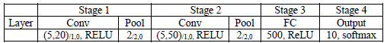
where (m, n)/a,b × c denotes c cascaded convolution layers with n filters of size m × m, where the stride and padding are a and b respectively. p/r,s denotes the max-pooling layers with window of p × p, where the stride and padding are r and s, respectively.
Train your network. The network would be trained via Cross Entropy with mini-batch GD. Describe the information that associated to the network training:
􀁸 Data Preprocessing, data augmentation (If any), initialization
􀁸 Optimal hyperparameters such as learning rate schedule, momentum coefficient, L2 coefficient, dropout rate, batch number etc.
Present them systematically in the table form.

(a) Plot the following:
􀁸 Training and test loss (not classification accuracy) vs epoch.
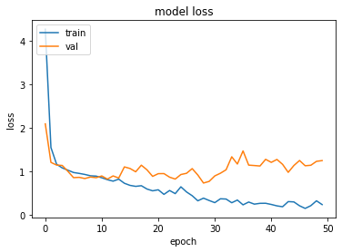
􀁸 Classification accuracy on the training and test set vs epoch.
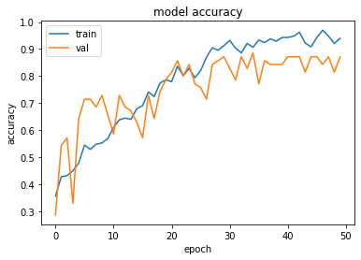
(b) Fill the table with the final accuracy that you obtained.

Training Accuracy (%) : 94%
Testing Accuracy (%) : 89%

2. Modify the CNN as follows
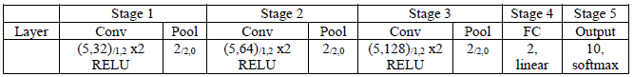
Train your network. Describe the information that associated to the network training:
􀂇 Data Preprocessing and data augmentation (If any)
􀂇 Hyperparameters such as learning rate schedule, momentum coefficient, L2 coefficient, dropout rate etc.

(a) After trained, input both training images (60,000) and test images (10,000) to the network, calculate the training/testing accuracy and collect the activation values (neuron output values) at stage 4, plot the activation distribution scatter plot as shown in Figure 1. Note this is a scatter plot for training data only, you must plot for both training and testing data.

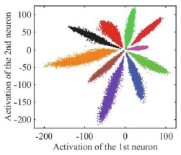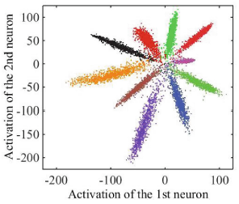

Figure 1: The distribution of deeply learned features in training set, under the supervision of CE loss. The points with different colors denote features from different classes.

(b) Discuss your observation on the plot and the relation with classification performance.

Learned features are separable, and deep features are still not discriminating sufficiently, as they still represent significant changes within the class. As a result, it is not appropriate to use these features directly for recognition.

